**Name**: Gia Dao.

**UTA student ID number**: 1001747062.

**Class**: CSE_1310_007.

**Date**: December, 1st, 2019.

I pledge, on my honor, to uphold UT Arlington's tradition of academic integrity, a tradition that values hard work and honest effort in the pursuit of academic excellence.

I promise that I will submit only work that I personally create or that I contribute to group collaborations, and I will appropriately reference any work from other sources. I will follow the highest standards of integrity and uphold the spirit of the Honor Code.

Student’s signature.

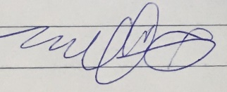

Gia Dao